PRESS RELEASE

COMMUNICATIONS AND MEDIA TEAM OF THE 2023 ASEAN SUMMIT

No.54/SP/TKM-ASEAN2023/ENG/5/2023

Cambodian PM Arrives in Labuan Bajo

West Manggarai, 9 May 2023 – The Cambodian Prime Minister Hun Sen became the first ASEAN leader to arrive for the 42nd ASEAN Summit in Labuan Bajo, West Manggarai, East Nusa Tenggara in 2023.

Hun Sen and his spouse Bun Rany arrived in Indonesia at approximately 13.09 local time and were greeted by the Minister of Health of the Republic of Indonesia, Budi Gunadi Sadikin, who was accompanied by the Ministry of Foreign Affairs’ Director General of Protocol and Consular Affairs Andy Rachmianto.

The arrival of the Cambodian leader and his entourage was accompanied by the performance of East Nusa Tenggara's traditional dances and music. Bun Rany received a bouquet from a couple East Nusa Tenggara kids, to which she responded by giving a kiss, demonstrating a warm atmosphere of the welcome.

Hun Sen and his entourage were then directed to their vehicles and headed to the meeting location for the 42nd ASEAN Summit 2023.

Indonesia serves as ASEAN Chair in 2023 after Cambodia previously passed the leadership baton to the country. Labuan Bajo will host the 42nd ASEAN Summit from 9 to 11 May 2023.

Indonesia raised the theme "ASEAN Matters: Epicentrum of Growth" during its ASEAN chairmanship, implying that ASEAN is relevant and significant as a global growth center.

Indonesia will also enhance the capacity and effectiveness of ASEAN institutions so that it can respond to challenges over the next two decades.

The 42nd ASEAN Summit 2023 will be attended by eight ASEAN country leaders, including the ASEAN Secretary General, and the Timor-Leste Prime Minister as an observer. (TR/Elvira/SC)

***

For more information, please contact:

Director General of Public Information and Communications of the Ministry of Communications and Informatics – Usman Kansong (0816785320).

Get other information at http://asean2023.id, https://infopublik.id/kategori/asean-2023, and https://indonesia.go.id/kategori/ragam-asean-2023

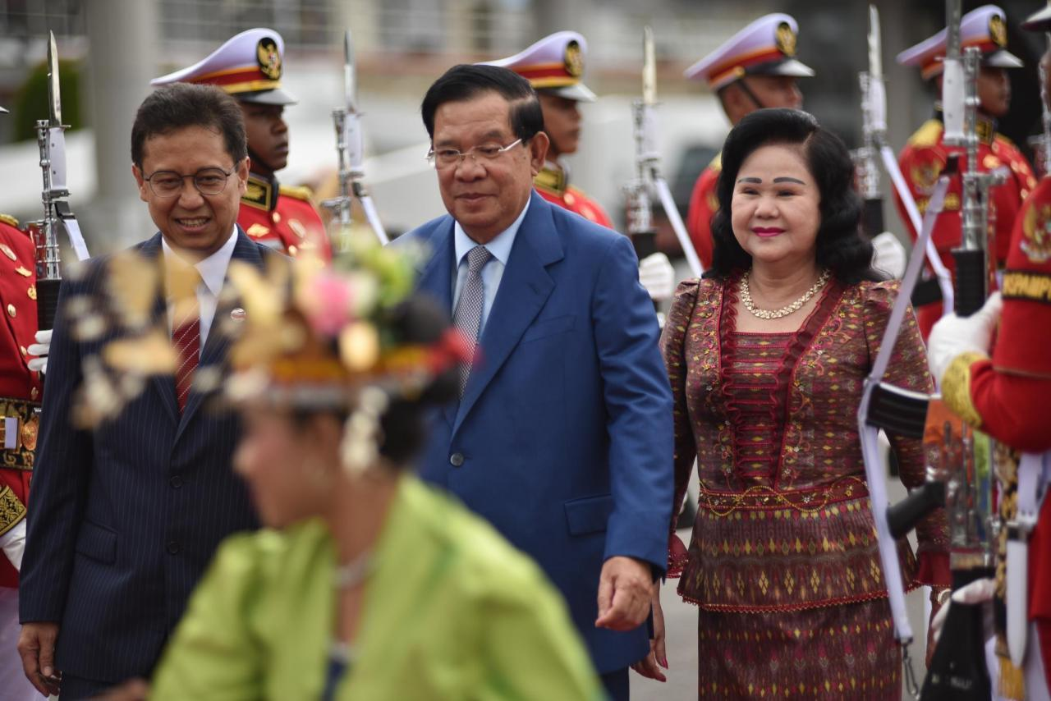

Cambodian Prime Minister (PM) Hun Sen is the first ASEAN leader to arrive in Labuan Bajo, West Manggarai, East Nusa Tenggara for the 42nd ASEAN Summit 2023. (Photo: ASEAN 2023 Host Photographer)

